STUDY OF BASIC NETWORK COMMANDS

**Aim:**

Introduction to basic network commands

1. **Ip configuration**

Use:

Displays all current TCP/IP network configuration values and refreshes Dynamic Host Configuration Protocol (DHCP) and Domain Name System (DNS) settings. Used without parameters, **ipconfig** displays the IP address, subnet mask, and default gateway for all adapters.

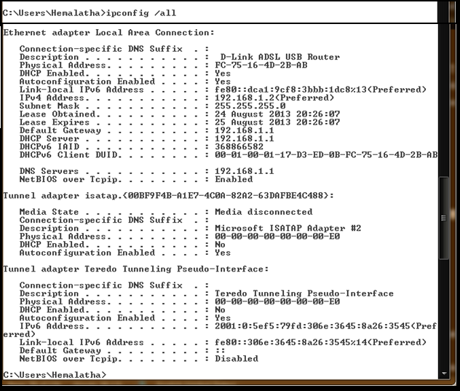

1. **Ping command**

Use:

If you are having connectivity problems, you can use the **ping** command to check the destination IP address you want to reach and record the results. The **ping** command displays whether the destination responded and how long it took to receive a reply. If there is an error in the delivery to the destination, the **ping** command displays an error message.

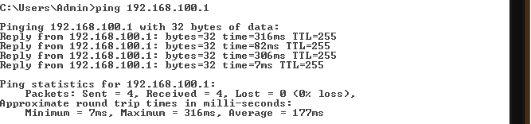

1. **Trace route command**

Use:

If you are having connectivity problems, you can use the **ping** command to check the destination IP address you want to reach and record the results. The **ping** command displays whether the destination responded and how long it took to receive a reply. If there is an error in the delivery to the destination, the **ping** command displays an error message.

1. **Pathping command**

The **pathping** command is a route tracing tool that combines features of the **ping** and **tracert** commands with additional information that neither of those tools provides. The **pathping** command sends packets to each router on the way to a final destination over a period of time, and then computes results based on the packets returned from each hop. Since the command shows the degree of packet loss at any given router or link, it is easy to determine which routers or links might be causing network problems.

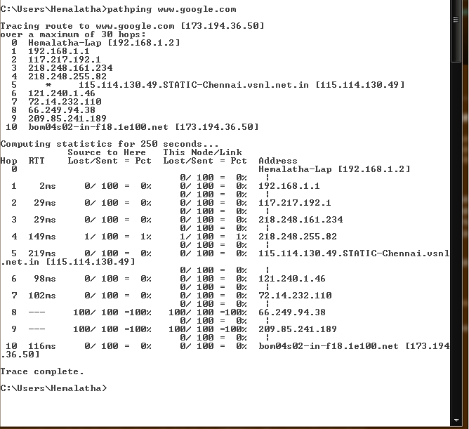

1. **arp command**

The address resolution protocol (arp) is a protocol used by the [Internet Protocol (IP)](http://www.erg.abdn.ac.uk/~gorry/eg3561/inet-pages/ip.html) , specifically IPv4, to map [IP network addresses](http://www.erg.abdn.ac.uk/~gorry/eg3561/inet-pages/ip-address.html) to the hardware addresses used by a data link protocol. The protocol operates below the network layer as a part of the interface between the OSI network and OSI link layer. It is used when [IPv4 is used over Ethernet.](http://www.erg.abdn.ac.uk/~gorry/eg3561/inet-pages/ip-enet.html)

The term address resolution refers to the process of finding an address of a computer in a network. The address is "resolved" using a protocol in which a piece of information is sent by a client process executing on the local computer to a server process executing on a remote computer. The information received by the server allows the server to uniquely identify the network system for which the address was required and therefore to provide the required address. The address resolution procedure is completed when the client receives a response from the server containing the required address.

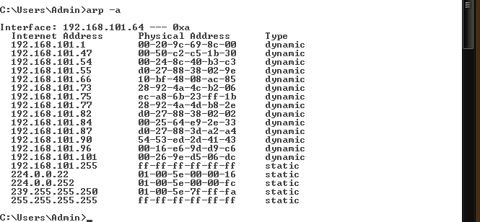

1. **hostname command**

Display the hostname of the machine the command is being run on. Additional information about the term hostname can be found on our [hostname dictionary definition](http://www.computerhope.com/jargon/h/hostname.htm).



1. **netstat command**

The netstat command is used to display the [TCP/IP](http://www.computerhope.com/jargon/t/tcpip.htm) network protocol statistics and information.

NETSTAT [-a] [-e] [-n] [-s] [-p proto] [-r] [interval]

|  |  |
| --- | --- |
| -a | Displays all connections and listening ports. |
| -e | Displays Ethernet statistics. This may be combined with the -s option. |
| -n | Displays addresses and port numbers in numerical form. |
| -p | proto Shows connections for the protocol specified by proto; proto may be TCP or UDP. If used with the -s option to display per-protocol statistics, proto may be[TCP](http://www.computerhope.com/jargon/t/tcpip.htm), [UDP](http://www.computerhope.com/jargon/u/udp.htm), or [IP](http://www.computerhope.com/jargon/i/ip.htm). |
| -r | Displays the routing table. |
| -s | Displays per-protocol statistics. By default, statistics are shown for TCP, UDP and IP; the -p option may be used to specify a subset of the default. |
| interval | Redisplays selected statistics, pausing interval seconds between each display. Press CTRL+C to stop redisplaying statistics. If omitted, netstat will print the current configuration information once. |

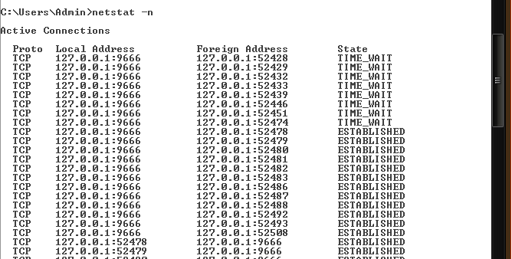

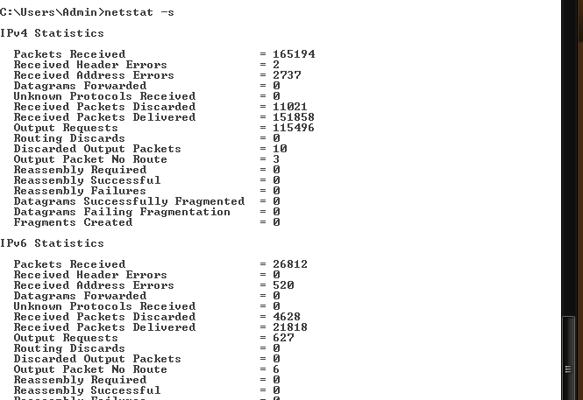

1. **route command**

Command to manually configure the routes in the routing table.

ROUTE [-f] [-p] [command [destination] [MASK netmask] [gateway] [METRIC metric] [IF interface]

|  |  |
| --- | --- |
| -f | Clears the routing tables of all gateway entries. If this is used in conjunction with one of the commands, the tables are cleared prior to running the command. |
| -p | When used with the ADD command, makes a route persistent across boots of the system. By default, routes are not preserved when the system is restarted. When used with the PRINT command, displays the list of registered persistent routes. Ignored for all other commands, which always affect the appropriate persistent routes. This option is not supported Windows'95. command |
| command | One of these:  PRINT Prints a route ADD Adds a route DELETE Deletes a route CHANGE Modifies an existing route destination |
| destination | Specifies the host. |
| MASK | Specifies that the next parameter is the 'netmask' value. |
| netmask | Specifies a subnet mask value for this route entry.  If not specified, it defaults to 255.255.255.255. |
| gateway | Specifies gateway. |
| interface | the interface number for the specified route. |
| METRIC | Specifies the metric, ie. cost for the destination. |

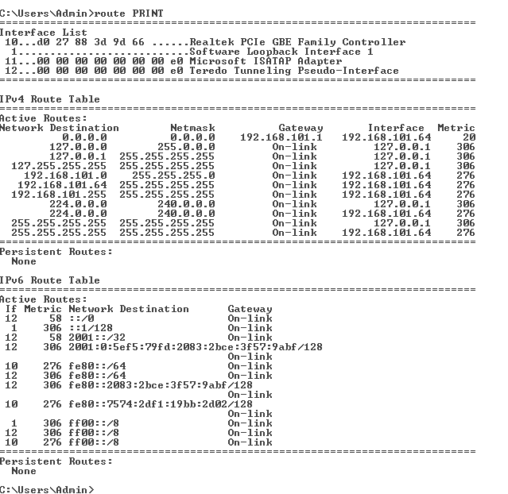

1. **nslookup command**

MS-DOS utility that enables a user to look up an IP address of a domain or host on a network.

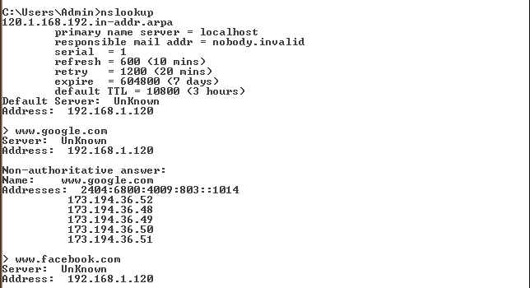

1. **nbtstat command**

Displays NetBIOS over TCP/IP (NetBT) protocol statistics,

NetBIOS name tables for both the local computer and remote computers, and the NetBIOS name cache. Nbtstat allows a refresh of the NetBIOS name cache and the names registered with Windows Internet Name Service (WINS).

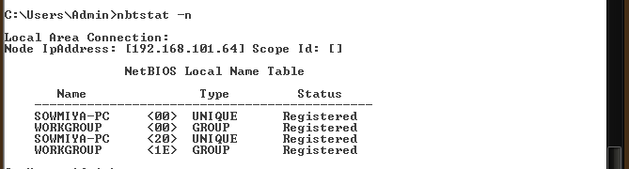

**BASIC NETWORKING COMMANDS**

1). netstat

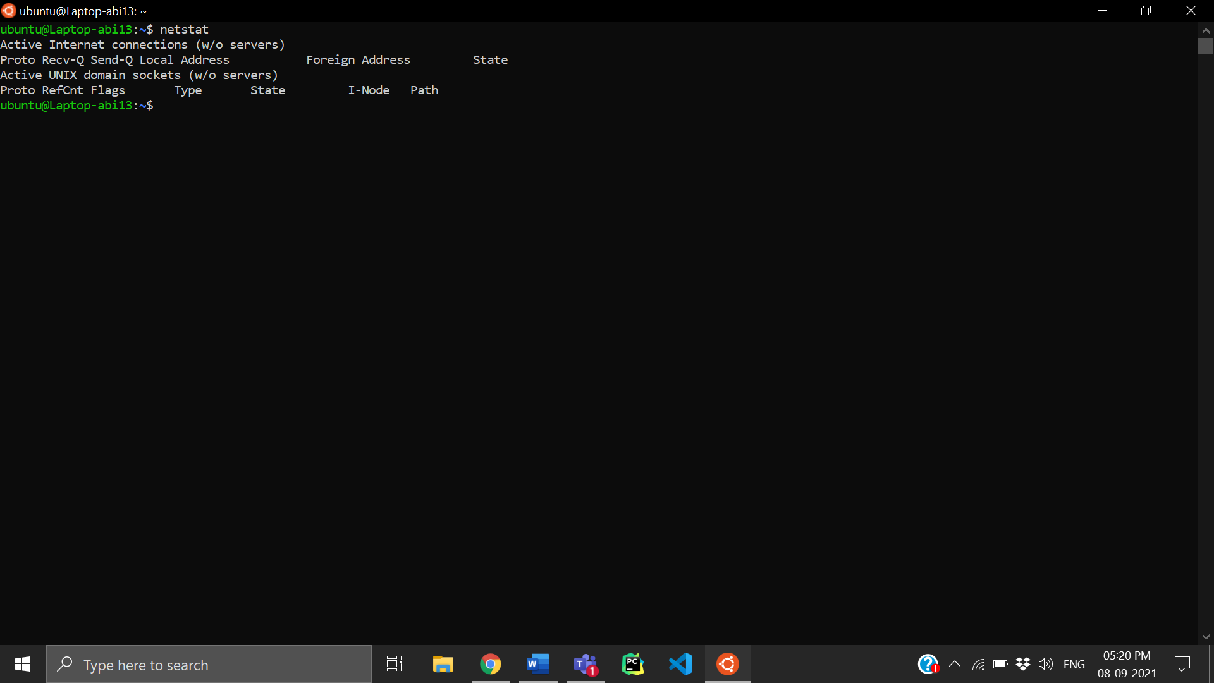

2) ifconfig

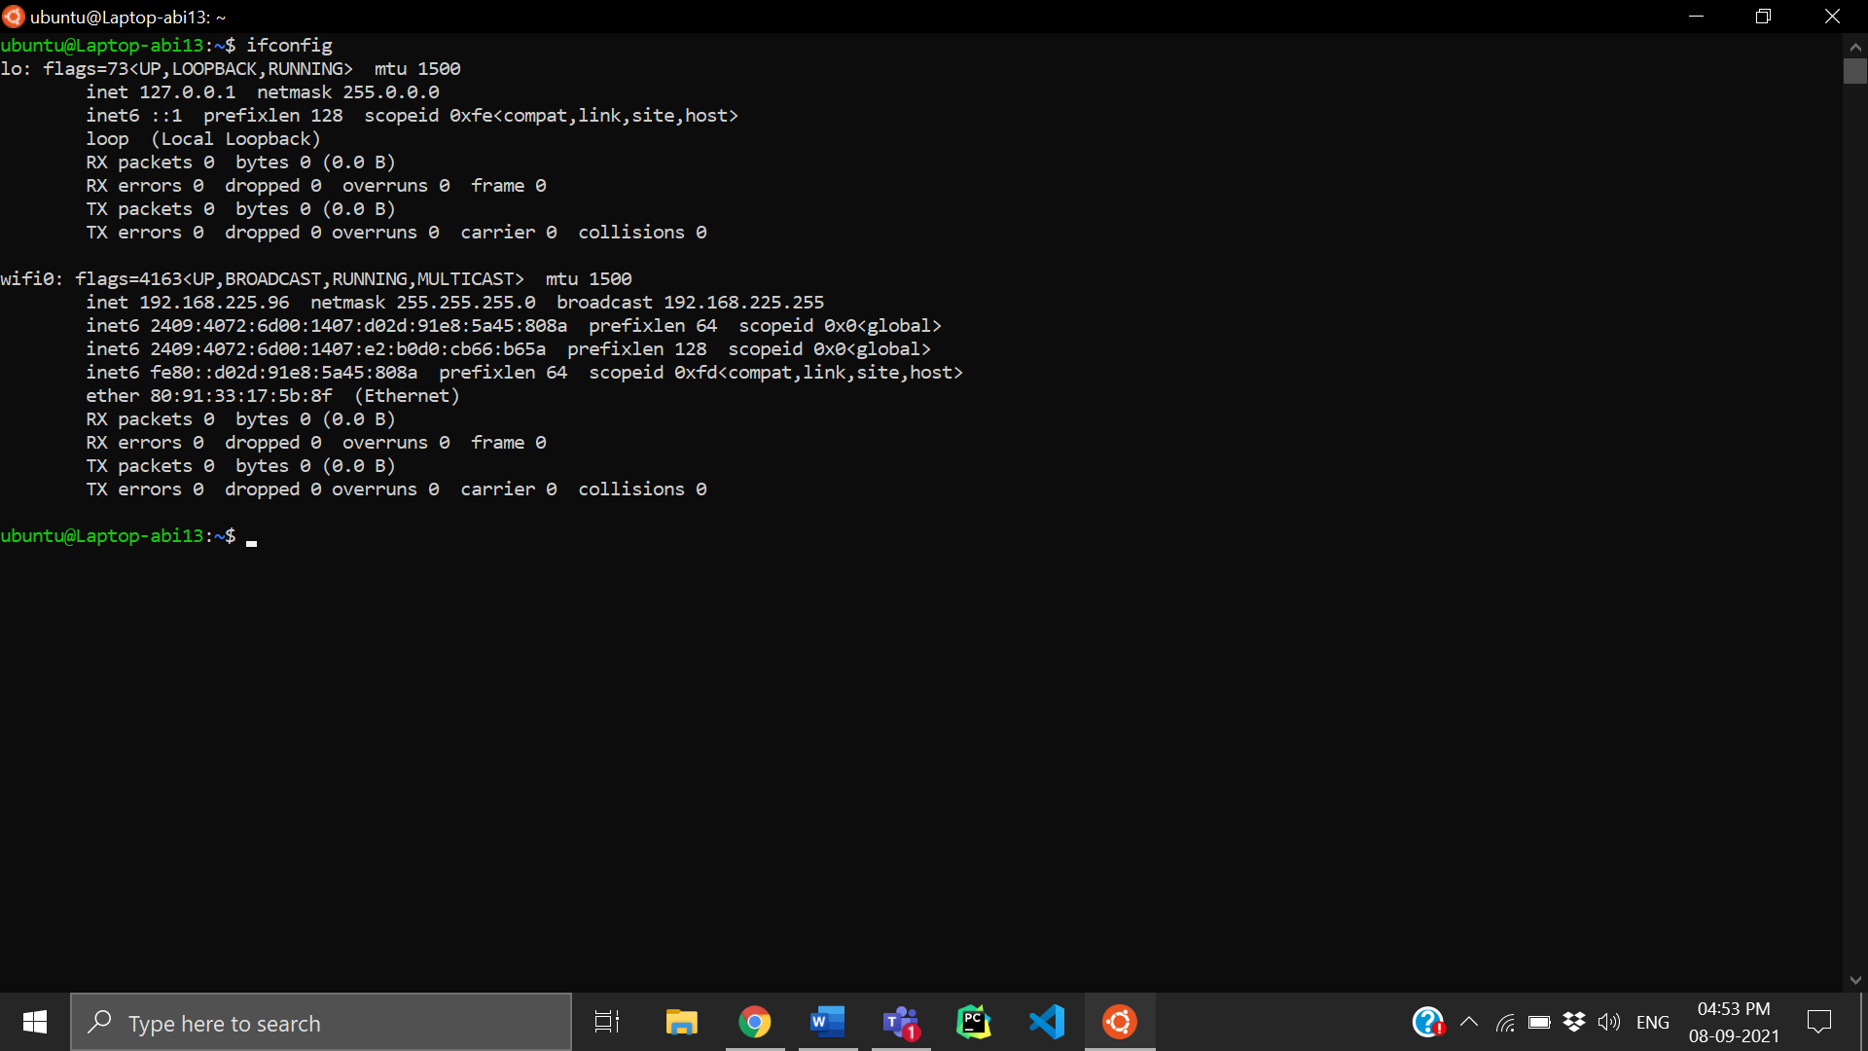

3) ping

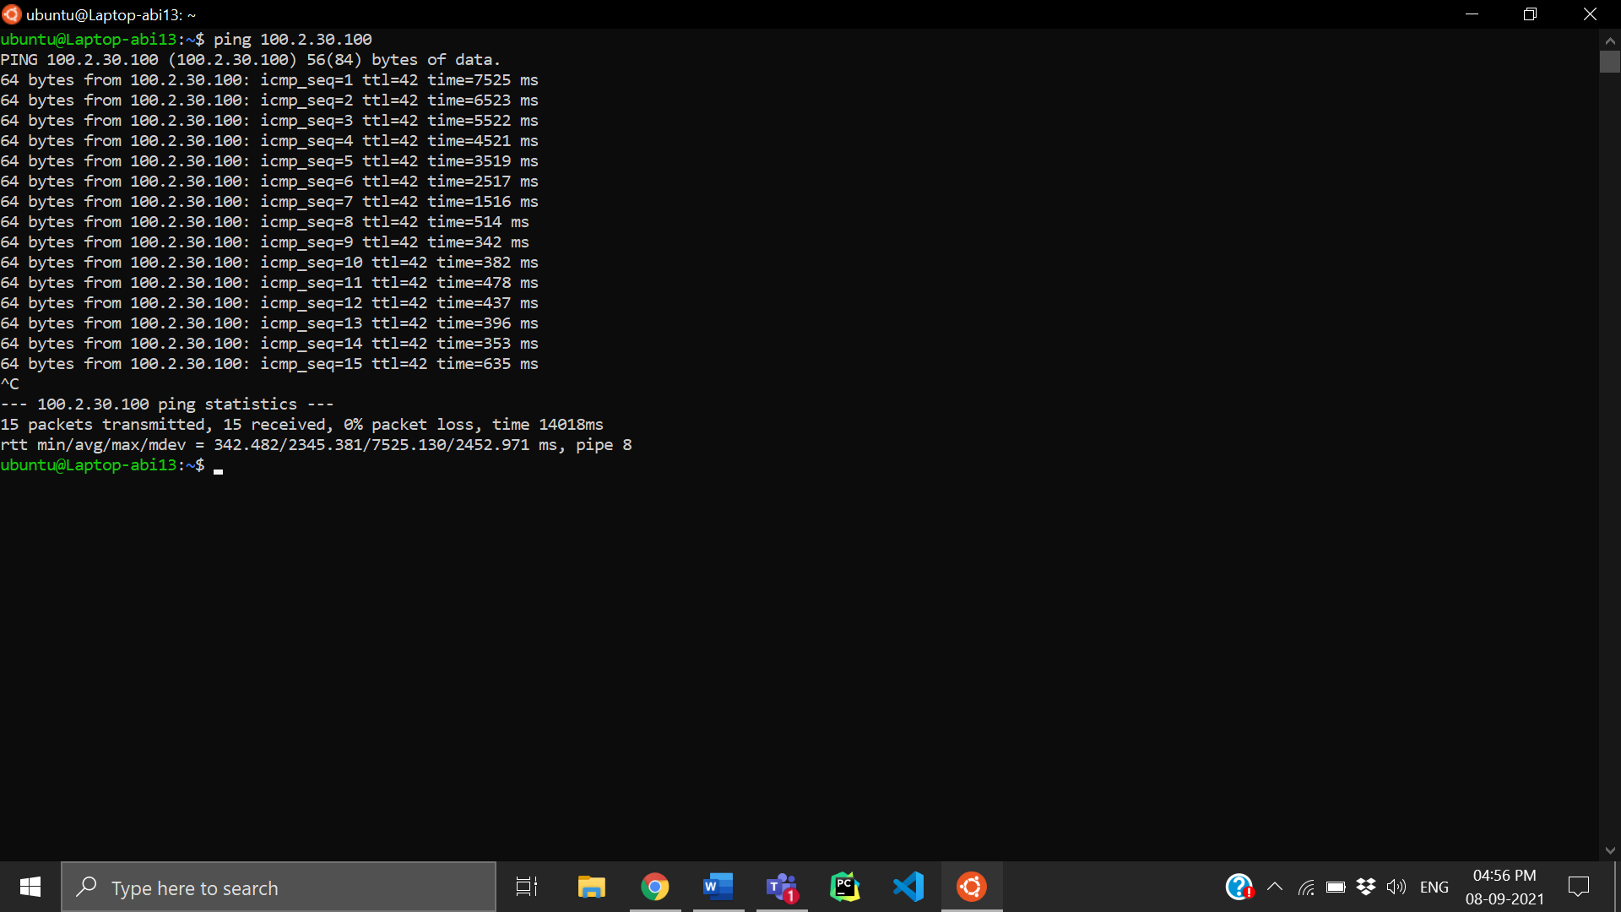

4) telnet

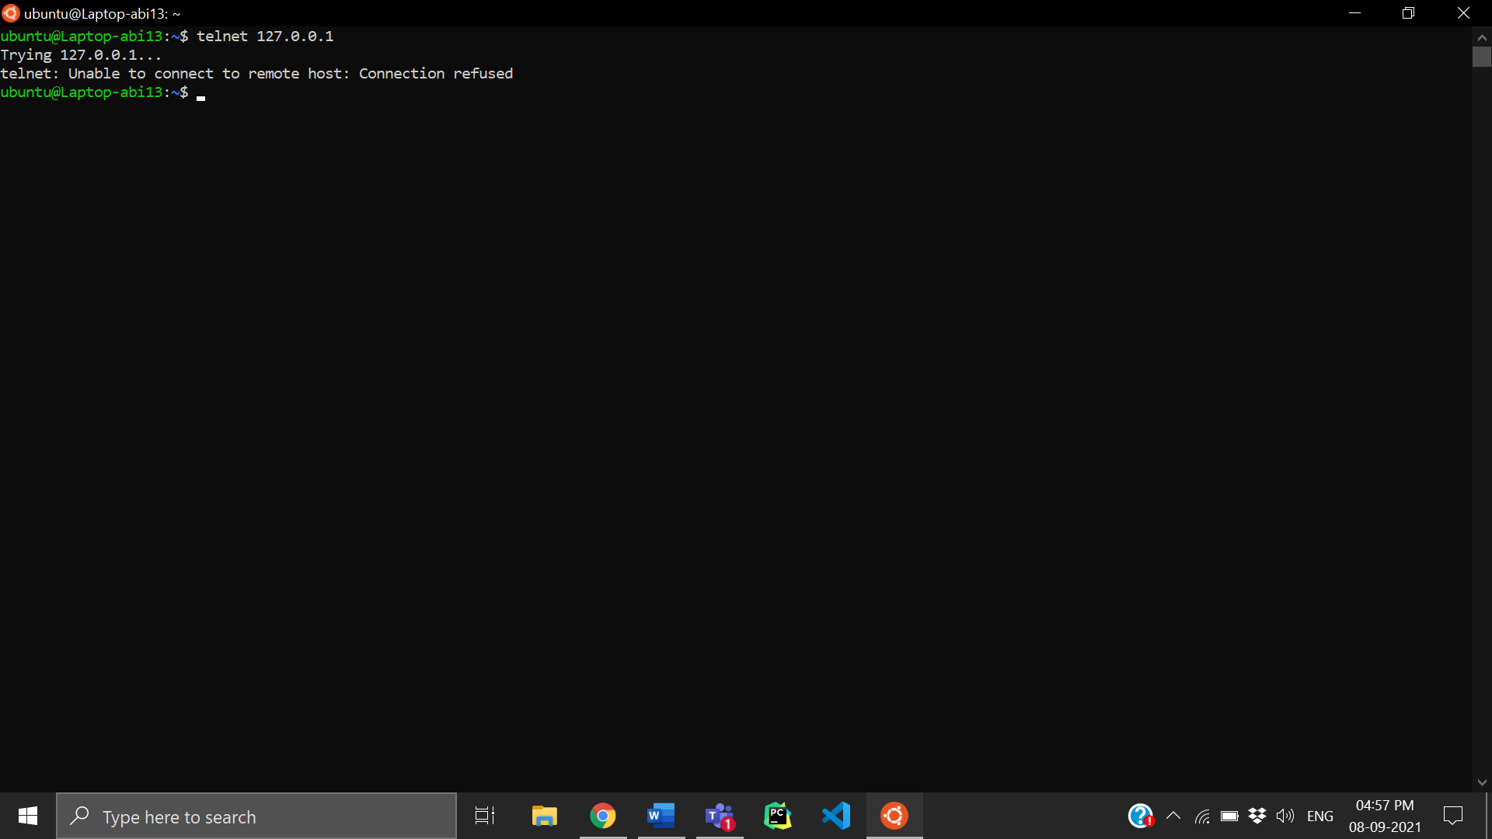

5) traceroute

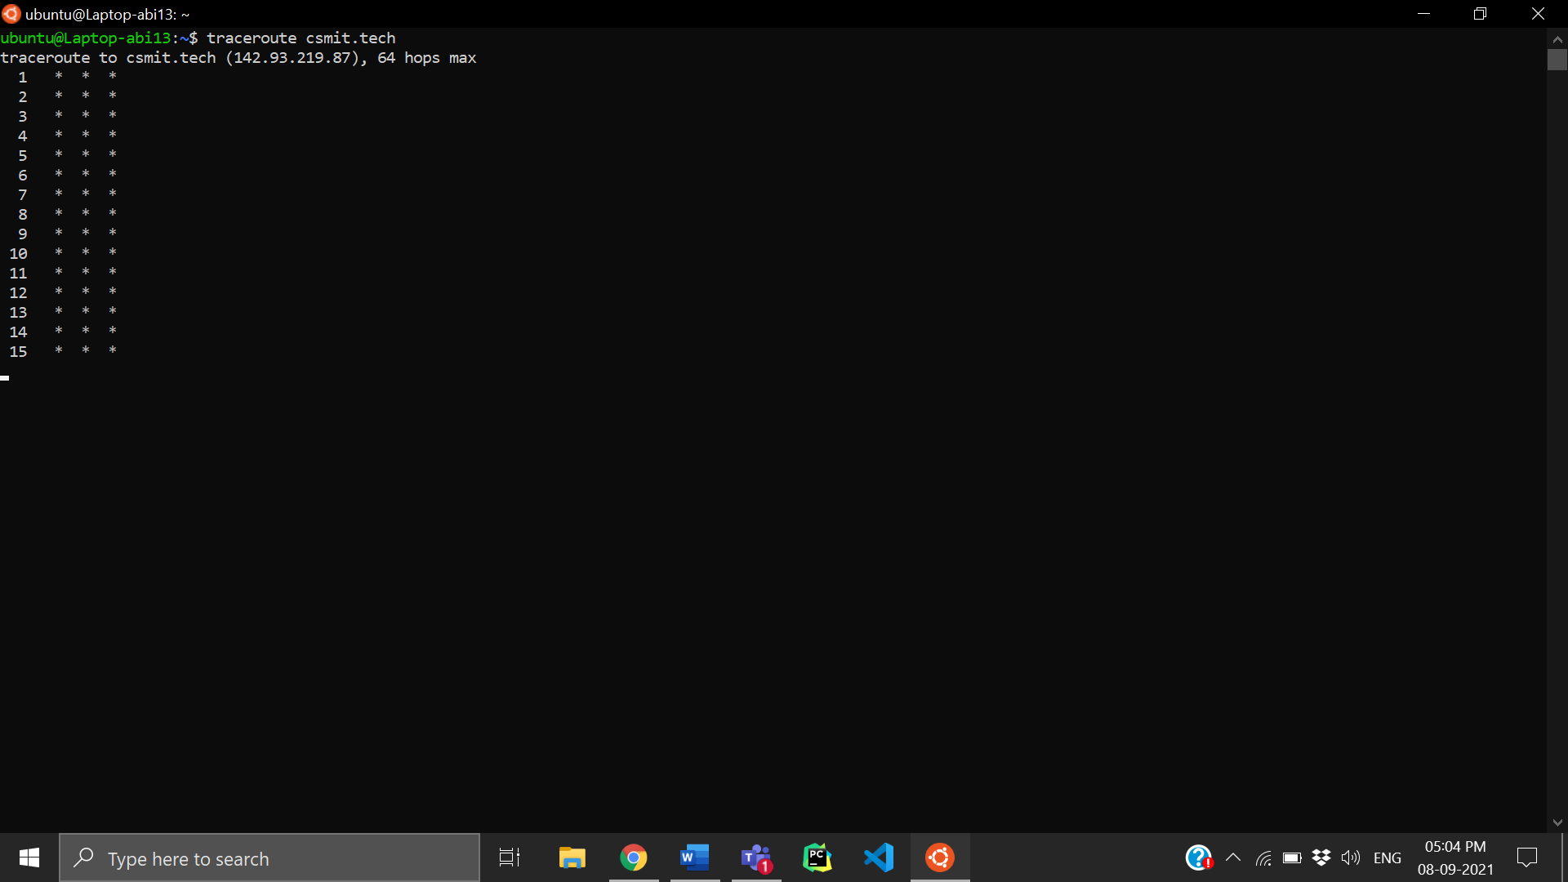

6) hostname

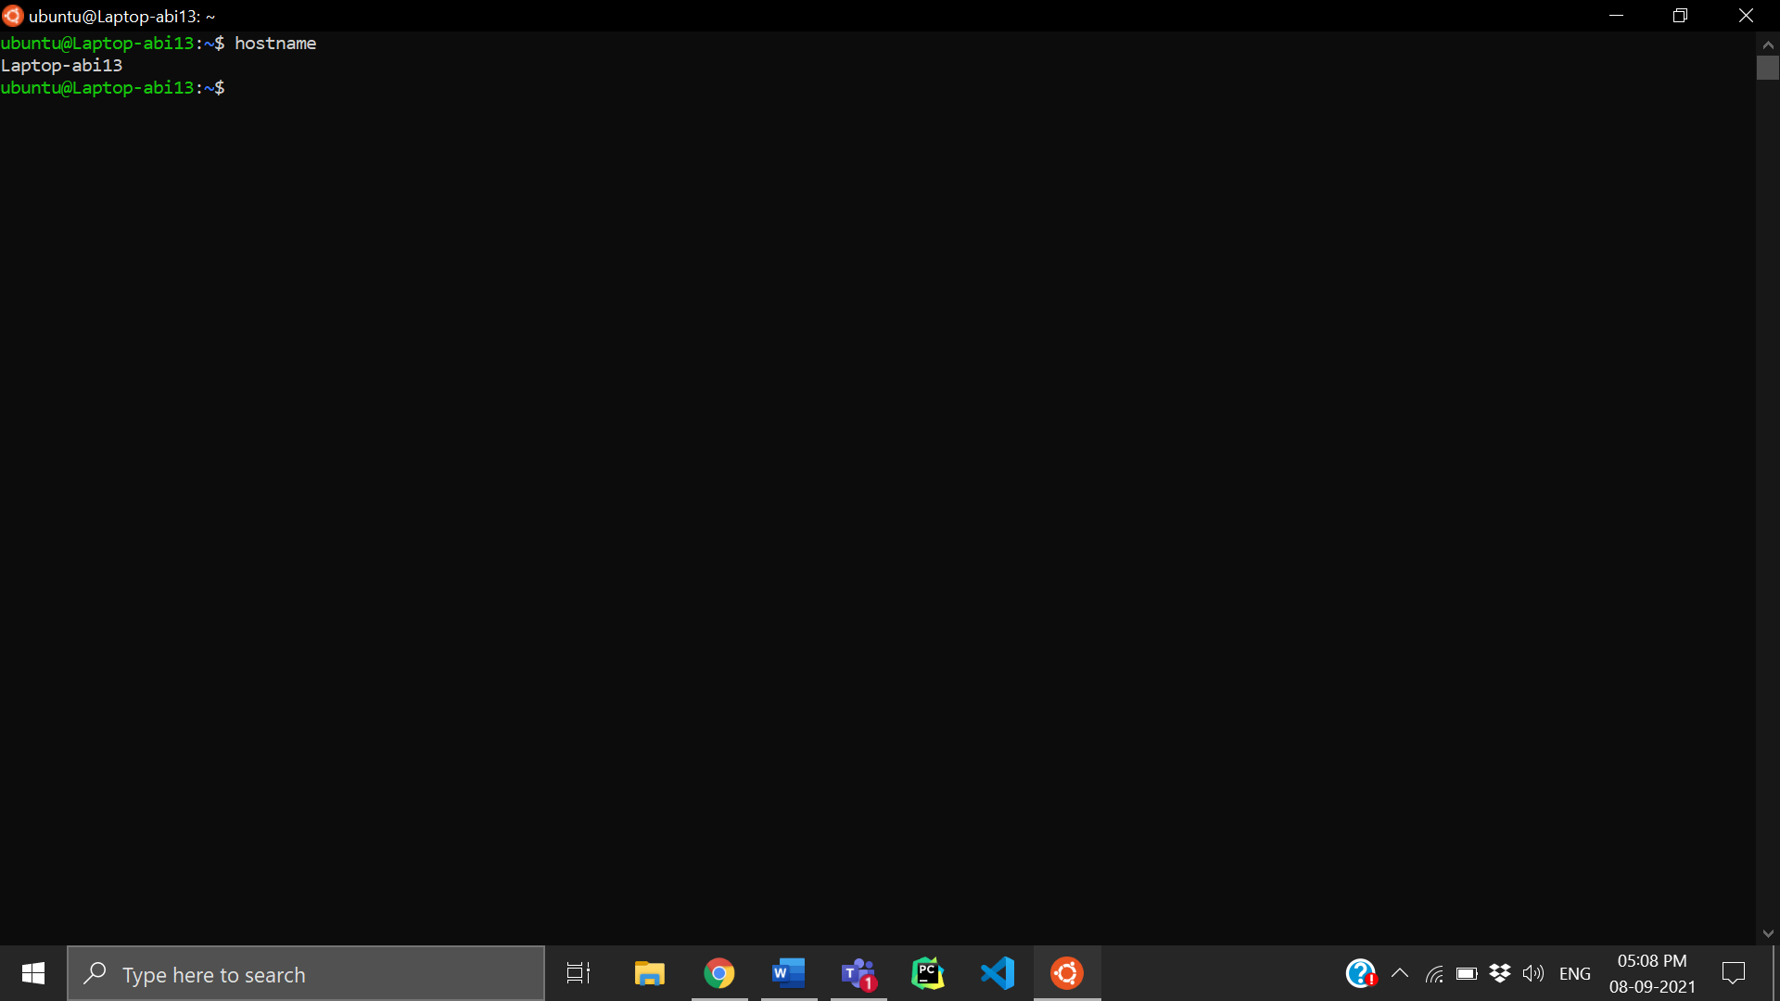

7) df

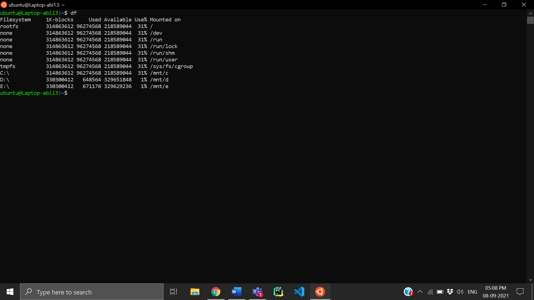

8) mount

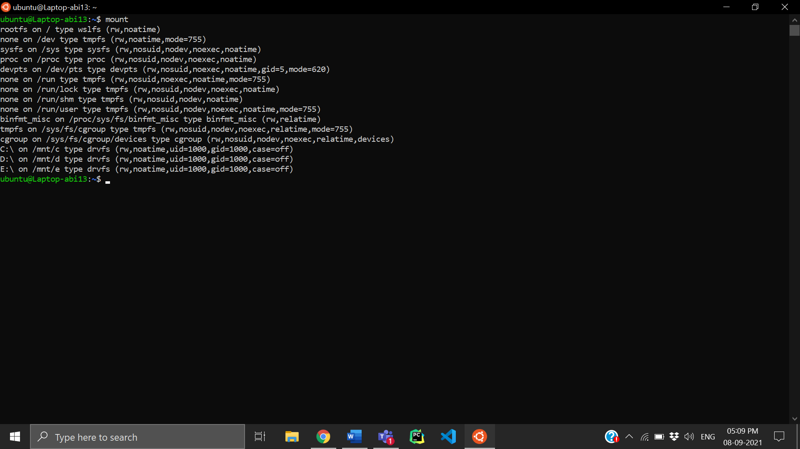

9) free

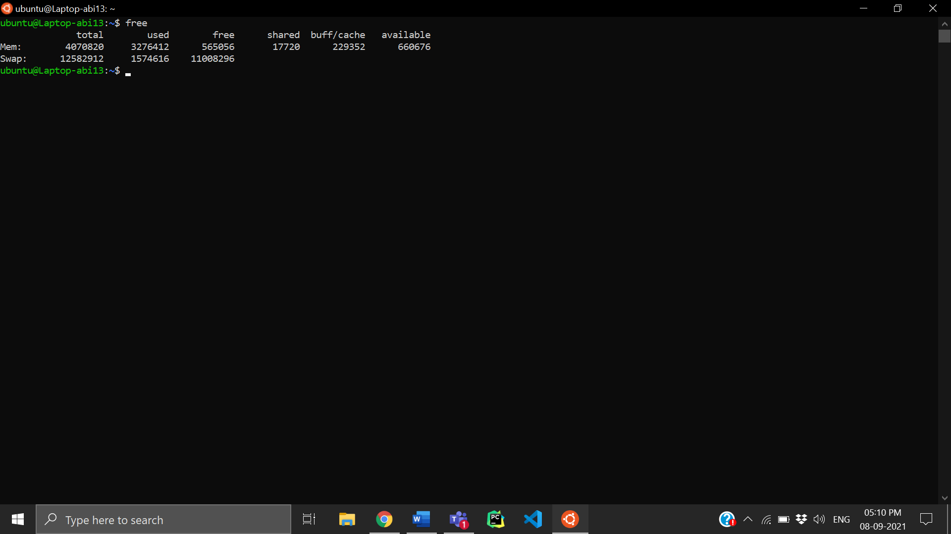

10) ps

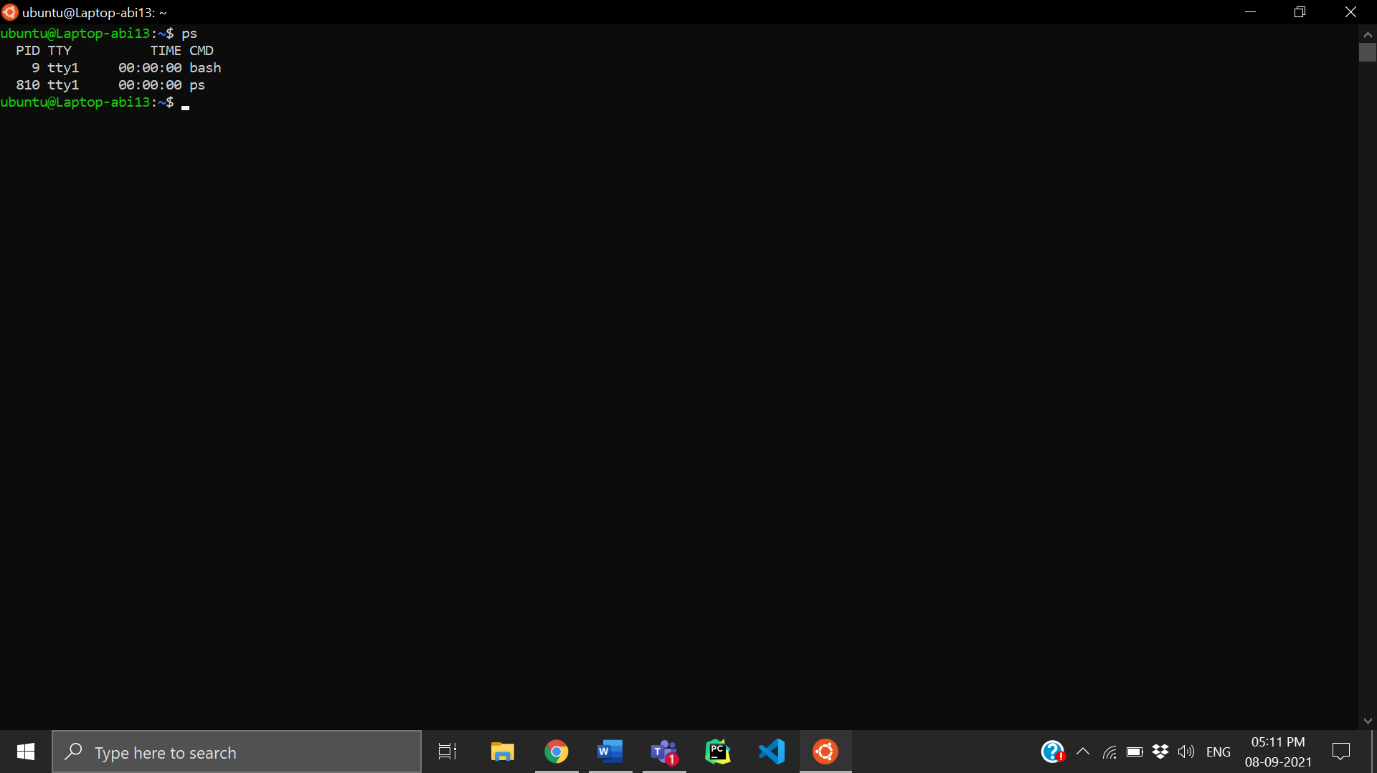

11) uptime

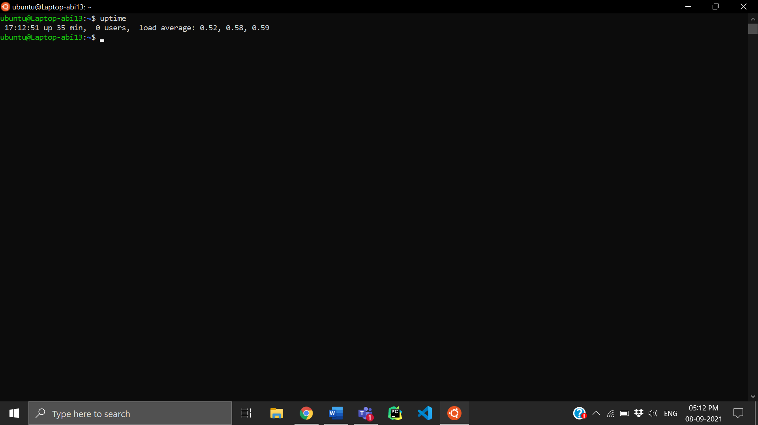

12) w

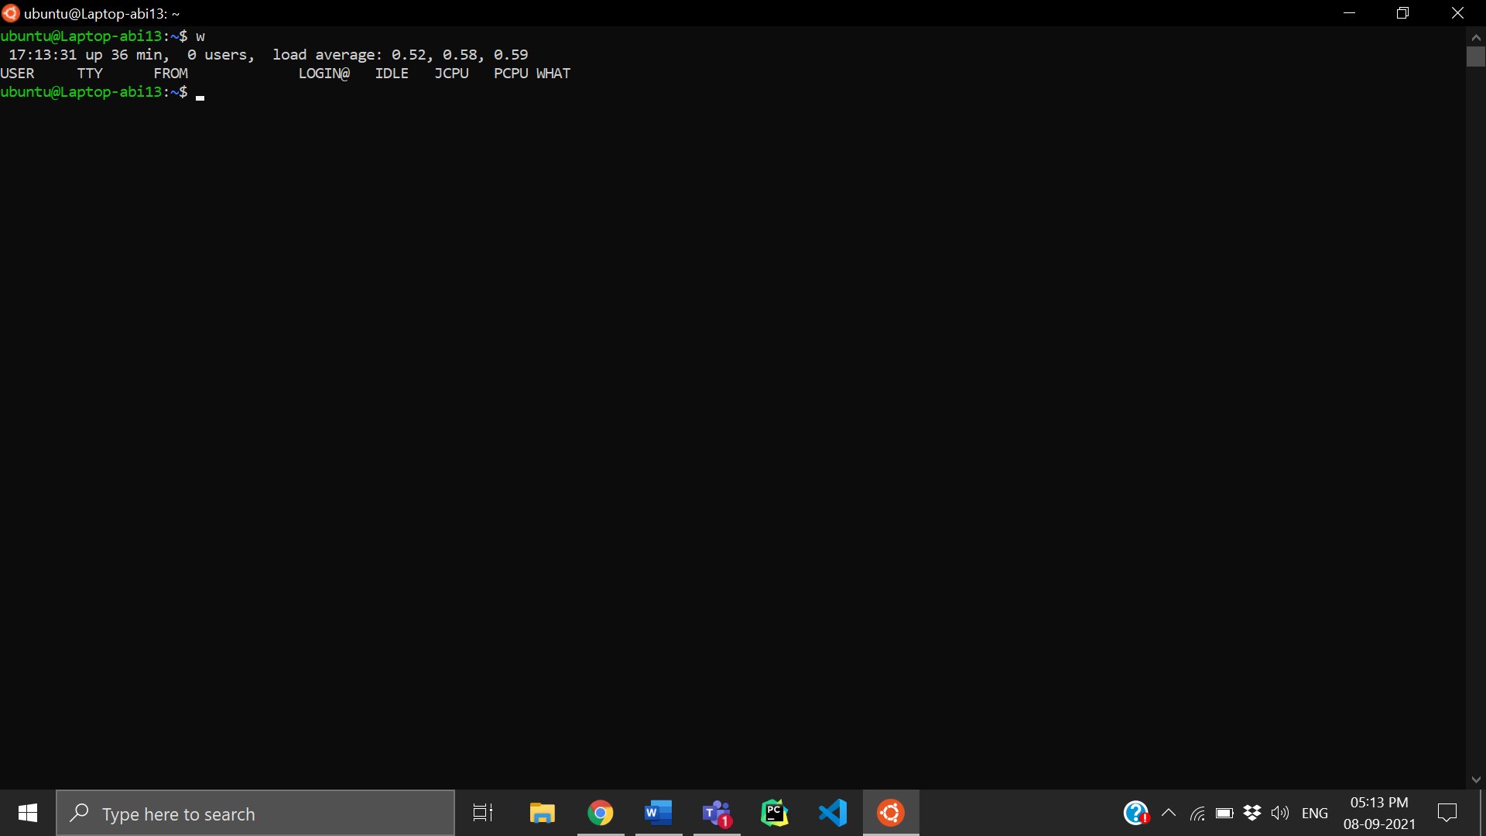

13) nslookup

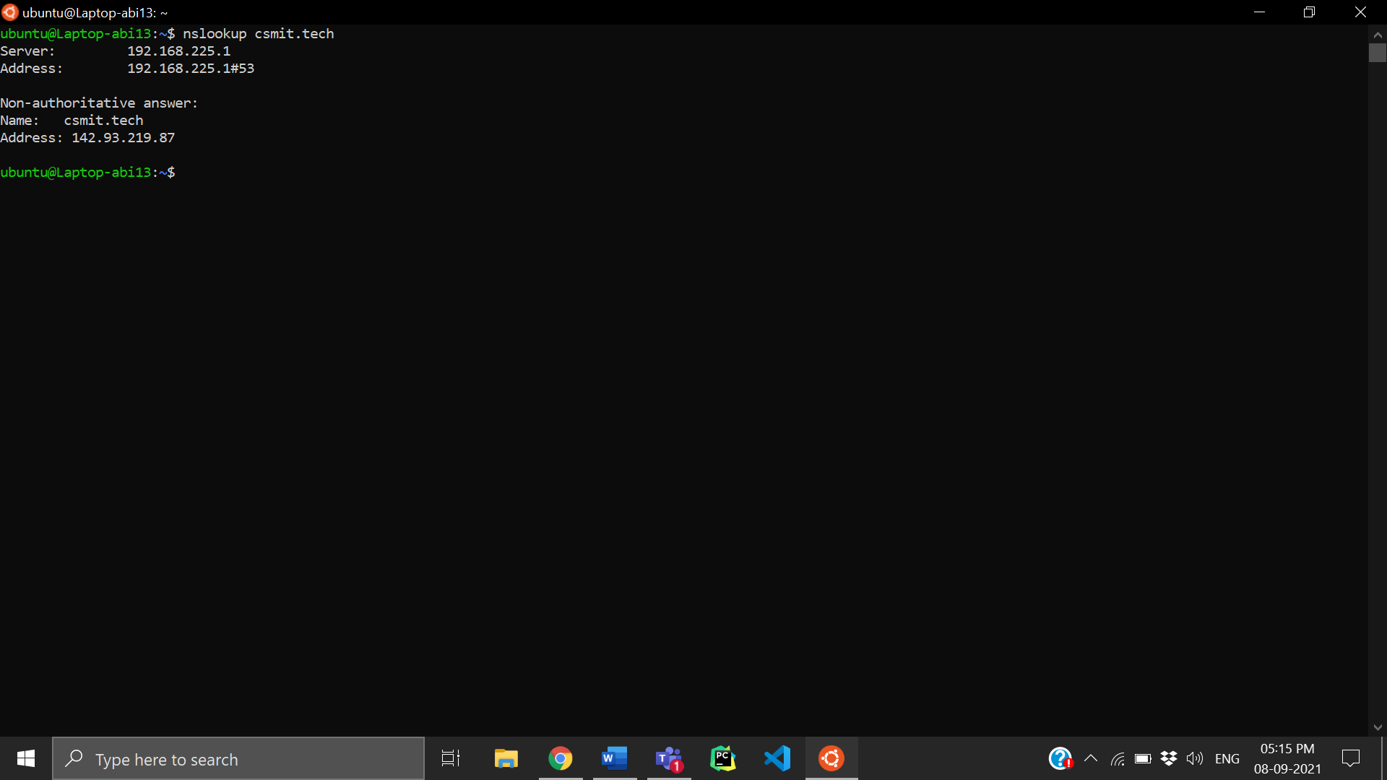

14) host

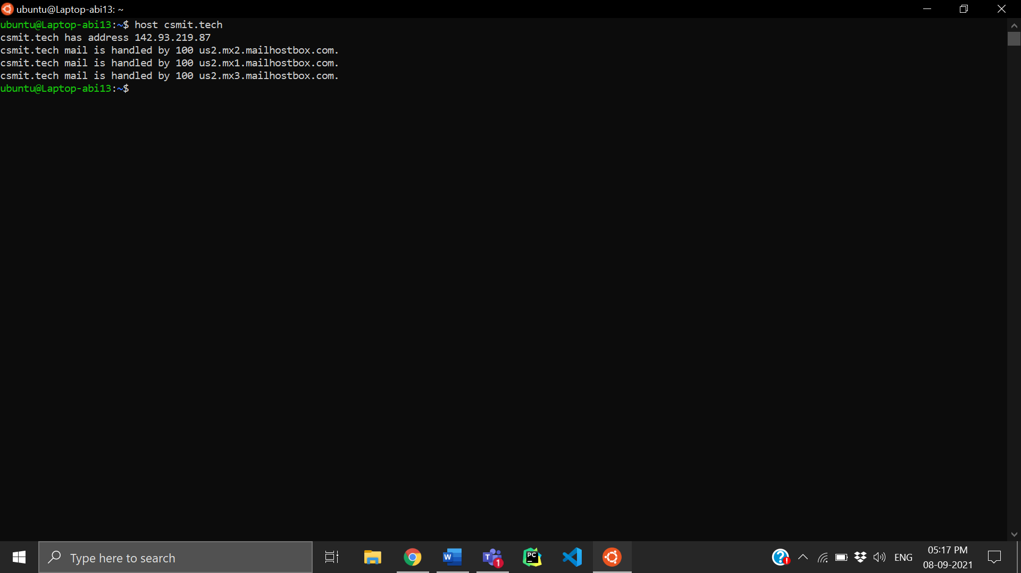

15) route

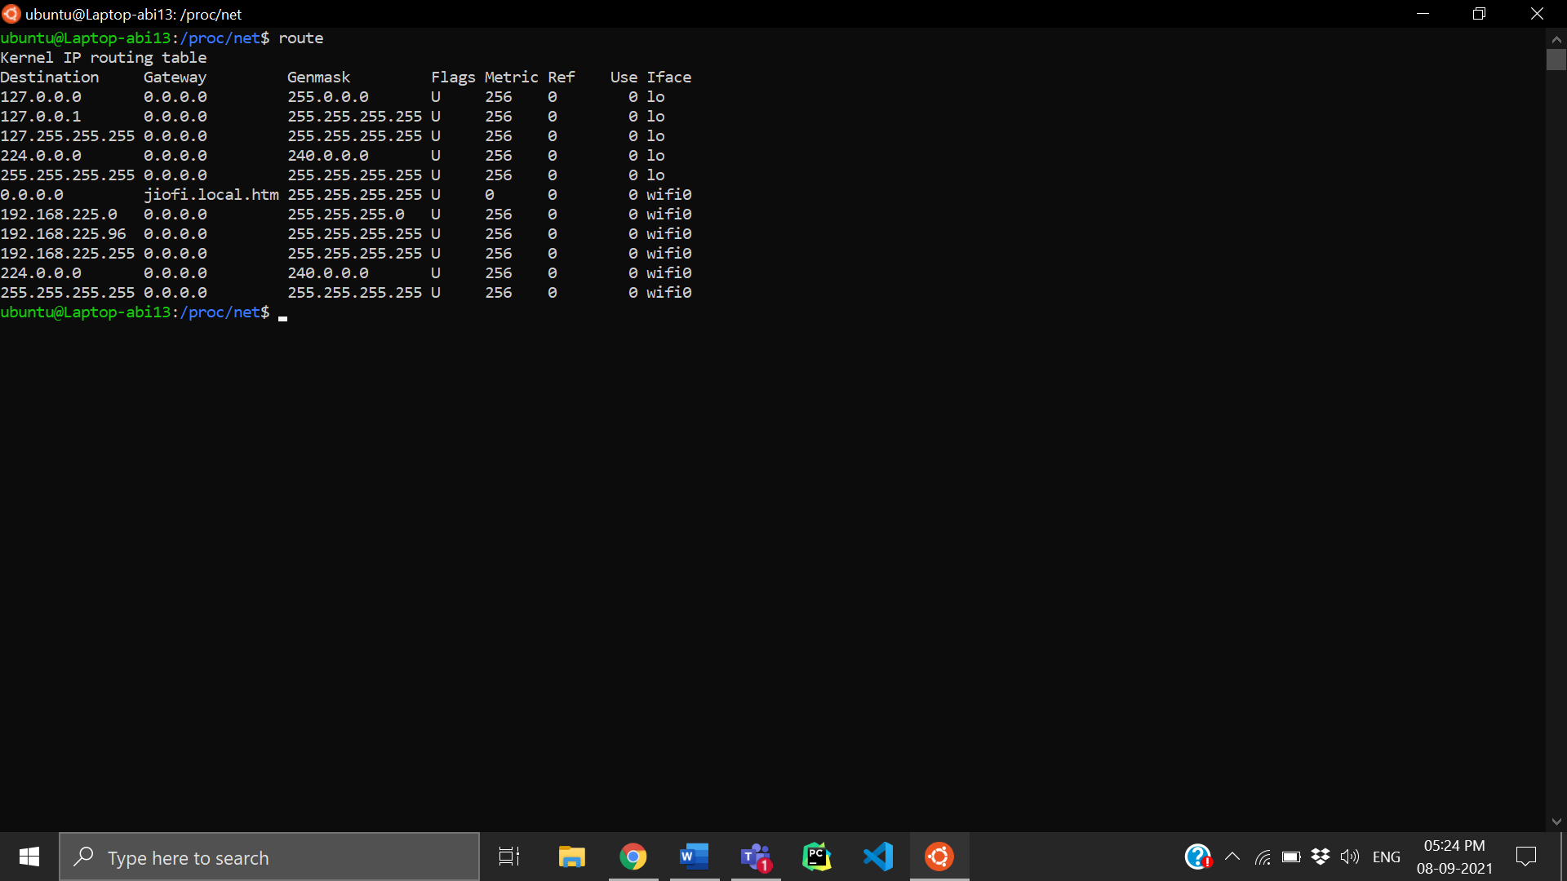

**RESULT**

Hence basic Unix networking commands are studied.